# Bracelet 3-Hand Watch

Price: $180.00 Color: Blue

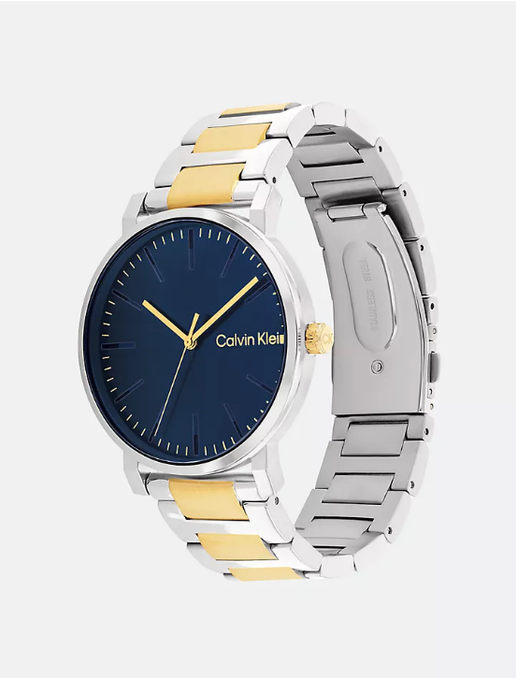

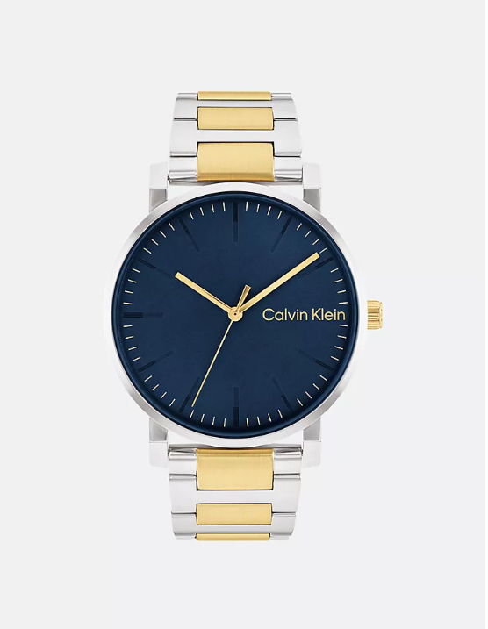

## **About the Bracelet 3-Hand Watch**

Effortless versatility for any season. Subtly angled lugs and diagonally brushed grey dial with nested indexes. This 3-hand movement piece is available on a stainless steel dual finish free-fall bracelet.

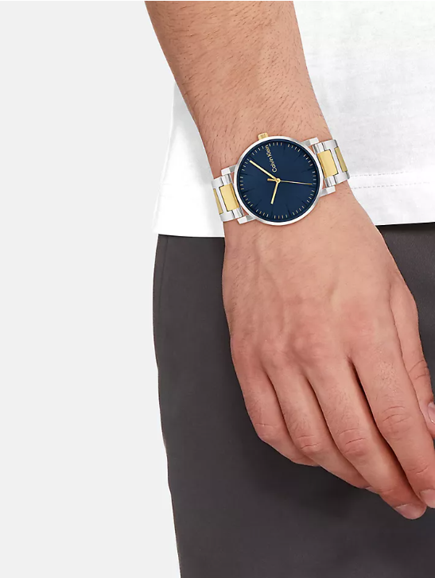Product details:

* Stainless steel or gold plated case
* Two-toned stainless steel or gold plated bracelet
* 3 hand design
* Clasp closure
* Imported
* 43mm case size
* Water resistant 5 bar
* 2 year international warranty
* All watches + jewelry come in a box

Style #: 43040258-460

Universal Style #: 25200258